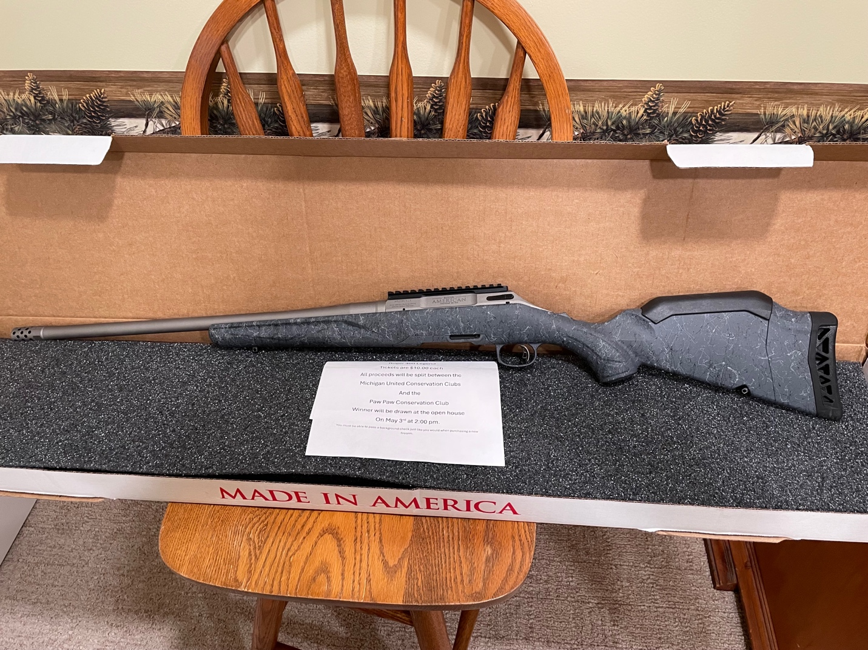
Gun Raffle
Ruger American 400 Legend
Tickets are $10.00 each
Proceeds to be split between
Michigan United Conservation Clubs
And the Paw Paw Conservation club
Drawing will be held May 3rd between 2 and 3 pm during the
Community open house. The open house is from 10am to 3pm and is open to the public. Come on out and see us and what we are about.
For any questions contact Dan Munson at 269-744-0885

